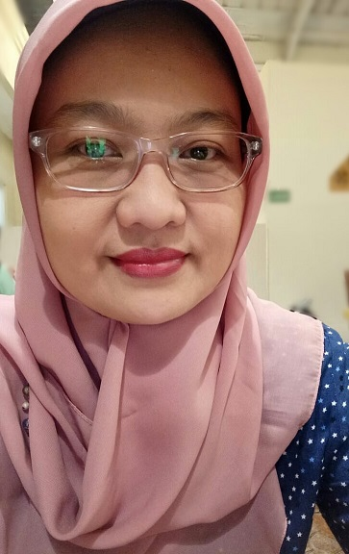 | ERIKA KARTAWIDJAJA  Jl .Mahkota Opal 66, Taman Viktoria, Sentul City, Bogor, 16810  • Cell: +62 821 25600905  • E-Mail: eri_kartawidjaja@yahoo.com

PROFILE
Name : Erika Kartawidjaja.
Place and Date of Birth : Cirebon, Juli 27th, 1981.

Marital Status : Married.
- Quick learner.
- Good at Analyzing System Requirements
- Speak English both oral and written.
- Good communication skill and interpersonal skills.
- Good administration skills.
- Accounting skills (Journal printing & calculation, ledger, petty cash, payroll calculation, AR/AP, PPh 21, PPn).
- Have knowledge about software licenses and its term of use.
EDUCATION
- Diploma 3, Management of Informatics; Institut Pertanian Bogor, Indonesia, 1999 – 2003 ( GPA : 3.40)
COMPETENCIES
Programming Language
- Java
- C#
- Visual Basic 6.0, VB.NET

DBMS
- Ms. Access, SQL Server, MySQL

Reporting Tools
- iReport
- Velocity
- Crystal Report
Other
- Pentaho

Framework
- Hibernate
- Spring
- Ext JS
IDE (Integrated Development Environment)
- Visual Studio
- IntelliJ IDEA

EXPERIENCES
SENIOR PROGRAMMER AND SYSTEM ANALYST, PT. Cahaya Buana Intitama, Bogor, October 1st, 2012 – Today
- Position as Staff IT at the main office
Main role as Java Programmer for Backend, but sometimes helped my partners by doing User Interface using Java Script (Ext JS), Hibernate, Spring, and reporting using Jasper Reports & Velocity
- Analyzing requirements and develop Trading & Manufacturing system that includes :
- Inventory
- Sales
- Purchasing
- Account Payable
- Account Receivable
- Cashier
- General Ledger (Accounting)
- Tax
- The system is used by 8 main Indonesian branch of current company.
- Training and Support

PROGRAMMER, PT. Cahaya Buana Intitama, Bogor, March 1st, 2006 – March 5th, 2012
- Position as Staff IT at the main office (main role as system analyst, developer, tester, implementator, and help desk).
- Develop and maintenance information system for each department such as :
- Accounting
- Payroll (HRD)
- Taxes (especially PPh 21).
- Create Report using Crystal Report for existing application.
- Making the User Manuals and documentation of the systems.
- Implement systems and deliver training to all user on site or at branch.
- Help Desk and troubleshooting (hardware/software/policys) to all user on site or at branch.
- Coordinating the MIS Team on helping other users.
- Control and organizing the hardware, software, and license data (hard copy and soft copy).
- Control the company policies on site or at branch (such as the license status of each pc, the procedure of data security, procedure of buying new hardware).
- Control the Purchase Order of hardware and software (start from making the recommended spesications, contact the suppliers, checking the invoice and payment arragement).

PROGRAMMER, PT. ALSYSINDO CONSULTING, Jakarta, October 1st, 2003 – February 28th, 2006
- System Analyst
- Develop Information system such as :
- Accounting system for Tanggerang City Government.
- SiSal (Sistem Informasi Salon) for The Salon at Dharmawangsa Square Jakarta.
- Simwasda (Sistem Pengawasan Daerah) for BAPEDA of Tanggerang City.

- Implement and deliver training for the client.
- Making the User Manuals and documentation of the systems.

Trainer, 2003-2006
- Accounting Trainer for all unit of Tanggerang City Government.
- Accounting Trainer for BKKSI (Badan Koordinasi Kabupaten Seluruh Indonesia).

Personal Projects
- Develop Payroll System for Mayora
- Develop Accounting and Budgeting Information System for Tangerang city government .
- Develop Accounting for PT. ISAMU (Paint Manufacturer)

Certificate

Java Training on November 2012 From PT. Artivisi Intermedia

